Asia-China-Coin-Qin 300-200 BCE-H 7.6 R10

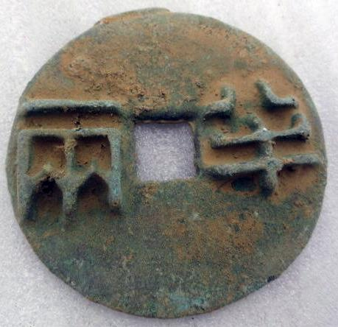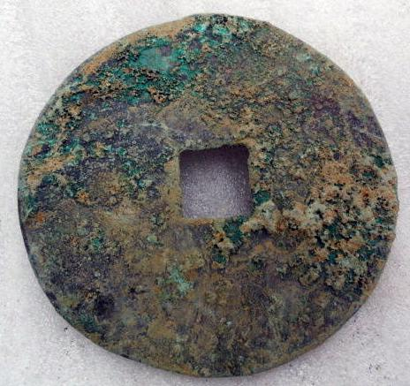

Ban Liang Coin, Qin Dynasty Type (300-200 BCE) weight:14g; size dia 3.5 cm, H 7.6 R10.

[Chinese bronze pattern tools of the trade Qin DY,sculpture,classical Round,rusty](http://www.ebay.com/itm/141151172510)

Item price

$10.99

Quantity

1

Item number

141151172510

Shipping service

ePacket delivery from China

[Leave feedback](http://feedback.ebay.com/ws/eBayISAPI.dll?LeaveFeedbackShow&useridfrom=802-867&useridto=lengxue&item=141151172510&transactid=905363203004) [Contact seller](http://contact.ebay.com/ws/eBayISAPI.dll?FindAnswers&frm=3998&iid=141151172510&redirect=0&requested=lengxue) [Return item](http://return.ebay.com/ws/eBayISAPI.dll?ResolveReturn&eventName=viewSelectedItem&TransactionId=905363203004&ItemId=141151172510)